AUTOMATING DATA IMPORT AND RELATIONSHIP MAPPING USING IMPORT SET AND DOT WALKING

Team Leader – Vignesh.J
Team members – Vishal.M , Vigneshwaran.S

INTRODUCTION
Data management is an important part of modern organizations. Many organizations store large amounts of data in different systems such as Excel sheets, databases, and external applications. Manually entering this data into systems is time-consuming and error-prone.
ServiceNow provides powerful tools like Import Sets and Dot Walking to automate the process of importing data and managing relationships between tables. Import Sets allow users to bring data from external sources into the ServiceNow platform, while Dot Walking helps to access related table fields easily.
This project focuses on automating data import and mapping relationships between tables using Import Sets and Dot Walking in ServiceNow.

OBJECTIVIES
The main objectives of this project are:
- To automate data import from external files into ServiceNow.
- To reduce manual data entry and errors.
- To map relationships between different tables.
- To access related fields easily using dot walking.
- To improve data management efficiency.

PROBLEM STATEMENT
Organizations often receive data in external formats such as Excel or CSV files. Manually entering this data into the system takes a lot of time and may cause mistakes.
Without proper relationship mapping, accessing related data becomes difficult. Therefore, there is a need for an automated solution that can import data and maintain relationships between tables efficiently.

TOOLS AND TECHNOLOGY USED
Tool / Technology |  | Purpose
ServiceNow |  | Platform used for implementation
Import Set |  | Used to import external data
Transform Map |  | Used to map imported data to target tables
Dot Walking |  | Used to access related table fields
Excel / CSV |  | Source data files
5. STSTEM ARCHITECTURE
The system architecture consists of the following components:
- Source Data
  - External data such as Excel or CSV files.
- Import Set Table
  - Temporary table where imported data is stored.
- Transform Map
  - Used to map fields from import set table to target table.
- Target Table
  - The final table where the data is stored.
- Dot Walking
  - Used to access fields from related tables.
WORKING OF IMPORT SET
Import Set is used to import data from external sources into ServiceNow.
Steps:
- Upload the data file (Excel / CSV).
- ServiceNow creates an Import Set table.
- Data is stored temporarily in this table.
- Transform Map is used to move data to the target table.
Benefits
- Reduces manual data entry
- Faster data import
- Easy data processing

TRANSFORM MAP
Transform Map is used to map fields between the Import Set table and the target table.
Functions
- Field mapping
- Data transformation
- Data validation
Example:
Import Set Field → Target Table Field
Employee_Name → Name
Employee_ID → Employee ID
Department → Department
Implementation Steps
- Prepare data in Excel or CSV format.
- Upload the file to ServiceNow.
- Create an Import Set table.
- Create a Transform Map.
- Map fields between source and target tables.
- Use Dot Walking to access related table fields.
- Test the data import process.

Advantages
- Saves time
- Reduces manual work
- Improves data accuracy
- Easy relationship mapping
- Efficient data handling

Applications
- Employee data management
- Incident management
- Asset management
- Customer information systems

Dot Walking
Dot Walking is a technique used to access fields from related tables.
Example:
If we have two tables:
- Incident Table
- User Table
Using Dot Walking:
incident.caller_id.email
Here:
- caller_id → reference field
- email → field from user table
Dot Walking helps to access related data easily without writing complex queries.
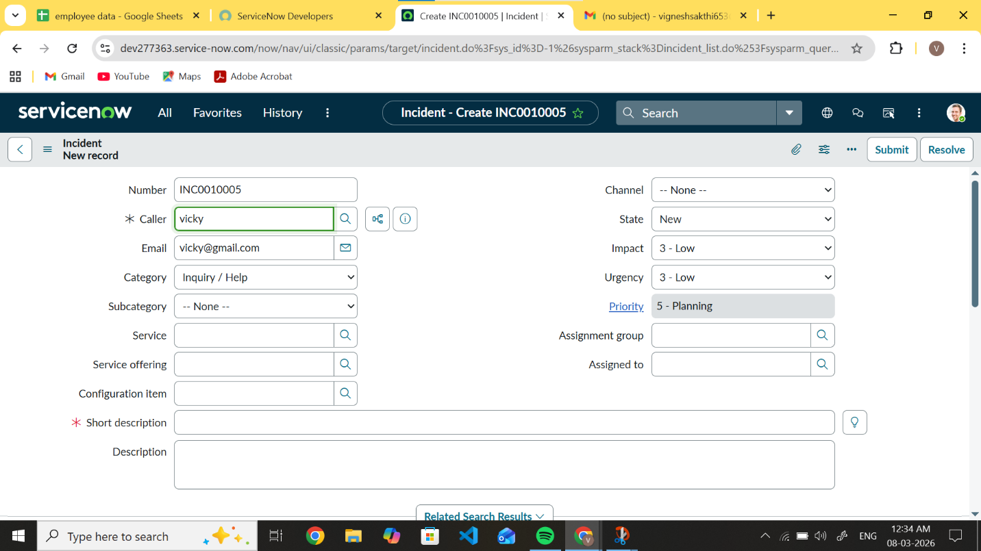

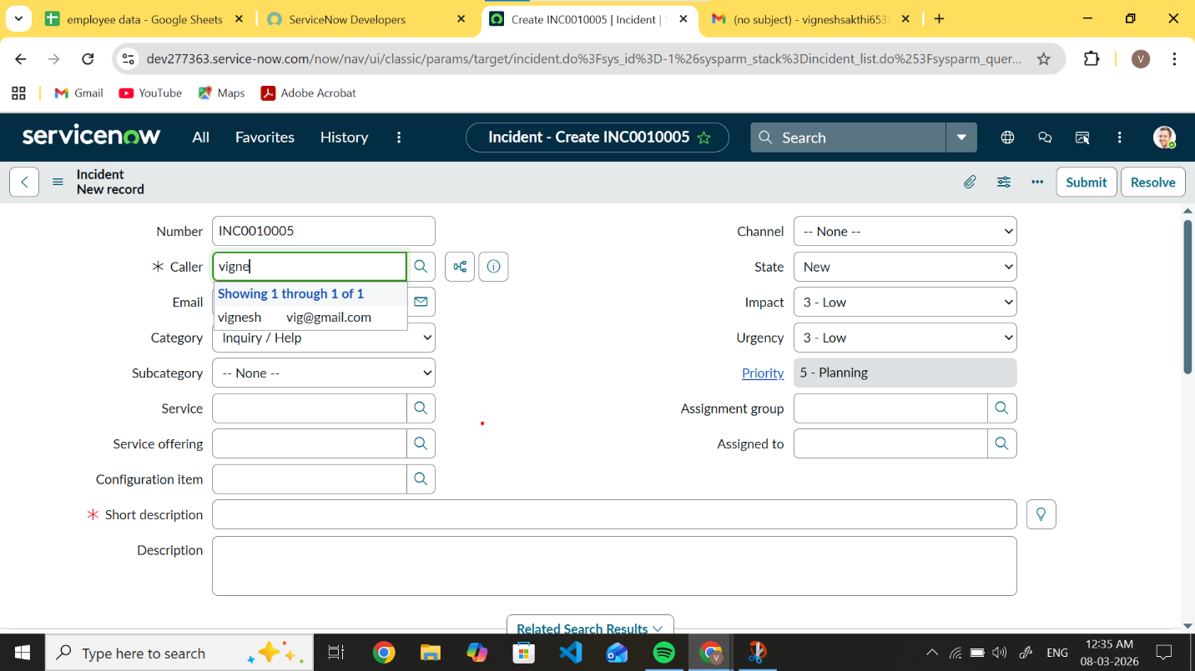
CONCLUSION

Automating data import using Import Sets and mapping relationships with Dot Walking significantly improves data management efficiency in ServiceNow. It helps organizations reduce manual work, minimize errors, and manage relationships between tables effectively. This approach ensures faster and more reliable data processing.

